aaBridge is a FREE computer app that run on both Windows and Mac.
You can get it from http://rogerpf.com/aaBridge or even easier just
Google aaBridge (one word) the site is normally at the top.
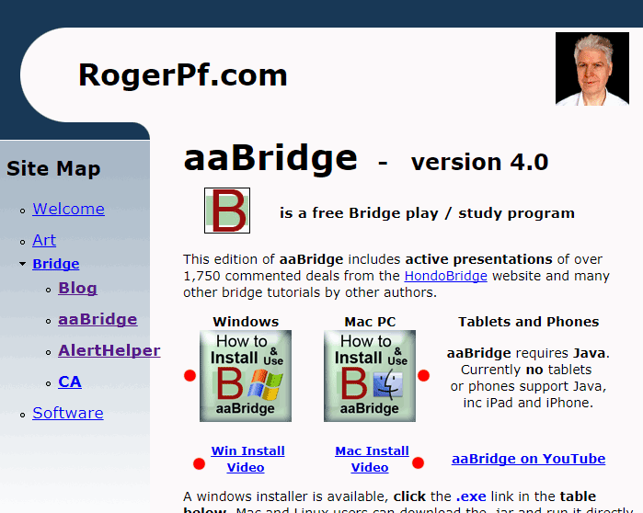
If the main website is unavailable see aaBridge File Archive (next page).
On the aaBridge page there are
Two big buttons that link to docs on – How two Install.
Two video links to YouTube, one for Windows, one for Mac.
See the red dots on the right >>>
Watch your video and then INSTALL aaBridge.


When you have installed aaBridge click the YouTube link on the front page.
Most of the Videos are VERY short 2-3 minutes.
Videos number 004 and 008 are a good place to start.

Now Try Menubar > Books-L > Writer - Angel Blue 2017
Menubar > Books-T > Teacher - Boldbida 2016
Yes - at first aaBridge is complex – It is like driving a car, you do need to, turn the wheel, look where you are going AND press the gas pedal ALL at the same time.
HINT - HOVER OVER THE BUTTONS when in aaBridge
But is it easy and natural one you get used to it.
Appendix - The aaBridge file archive on Google Drive
If the normal aaBridge website is unavailable you can use Google Drive.
Follow the link aaBridge on Google Drive
If trying to follow that link from within this document gives any problems:
Copy and Paste the (shortened google link) text below into your browsers address bar.
https://goo.gl/BTCVRj

When this opens you should be in aaBridge_releases on Google Drive. Look in the top right hand corner if you can see the 3 bars icon (red dot), I strongly advise you to click it.
That way the long file names will be readable.
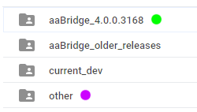
Go into the first folder, (green dot). Windows users can double-click to enter.
This is the current release of aaBridge so it will have a folder name like
aaBridge_4.0.0.3168

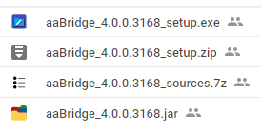
In that folder is aaBridge...setup.exe for Windows
and the .jar for Macs.
You can right click and select download OR
double click and then click the 'download' button.


Go into the folder named other (purple dot above)
The detailed install guides will be at the end of the list of files both start zzz...

<end document>

